Premium Arabica Coffee Beans (AAA & AA Grade)
By The Export Express

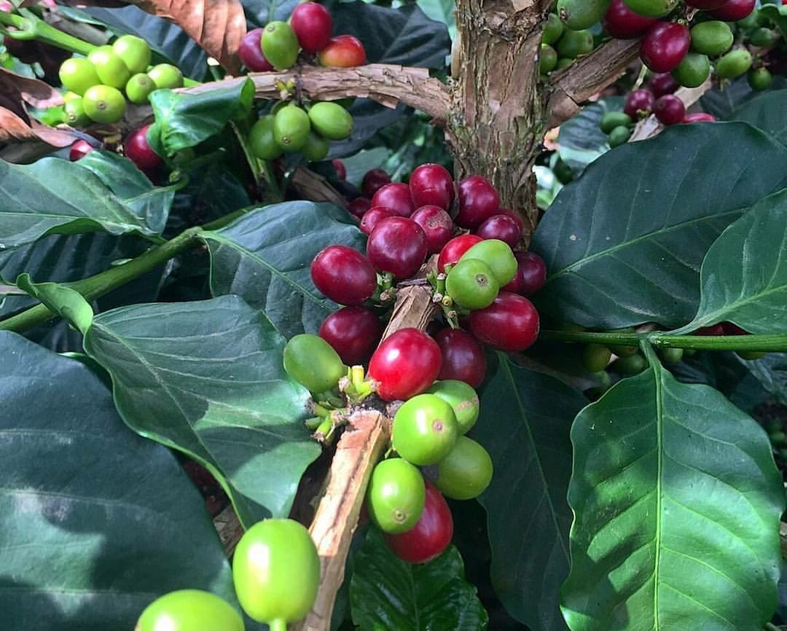

Introduction
The Export Express proudly presents premium Arabica coffee beans, cultivated in high-altitude regions of India where the climate, soil, and rainfall create the perfect environment for world-class coffee production. Known for their smooth taste, rich aroma, and balanced acidity, our Arabica beans are carefully handpicked, naturally processed, and graded to international export standards.
We specialize in two of the finest Arabica grades — AAA and AA, available in both green (unroasted) and roasted forms. Each grade is distinct in flavor, aroma, and appearance but united by a shared hallmark of excellence — a commitment to purity, freshness, and consistency.
Our coffees are ideal for roasters, cafés, retailers, and gourmet coffee brands seeking authentic Indian Arabica with unmatched export quality.

About Arabica Coffee
Arabica coffee (Coffea arabica) accounts for nearly 60% of the world’s coffee production and is celebrated for its refined flavor profile, low bitterness, and naturally sweet aroma. Cultivated primarily at elevations above 1,000 meters, Arabica thrives in cool temperatures and rich volcanic soils, producing beans that are aromatic, delicate, and flavorful.
At The Export Express, we source our beans from high-altitude plantations where sustainable farming practices and hand-harvesting ensure that only fully ripened cherries are processed. This meticulous care at every stage — from cultivation to drying — defines the superior quality of our Arabica offerings.

The Export Express Arabica Collection

1. Arabica AAA Grade Green Coffee Beans
Grade: AAA
Form: Green (Unroasted)
Roast Level: Non-roasted
Color: Green
Shelf Life: 2 Years
Packaging Type: Gunny Bag / Bulk Loose
Availability: In Stock

Key Highlights
- Premium Quality: Our AAA grade beans represent the highest level of Arabica excellence, sourced from high-altitude estates known for exceptional soil fertility and organic cultivation.
- Superior Aroma & Flavor: Characterized by a mild, delicate body with floral undertones, chocolatey depth, and a clean aftertaste.
- High in Antioxidants: Contains abundant chlorogenic acid, supporting metabolism and overall wellness.
- Ideal for Roasters: The uniform bean size and moisture balance make these perfect for custom roasting, ensuring consistent quality for export buyers.

Usage & Applications
Arabica AAA green coffee beans are ideal for:
- Custom roasting operations for cafés, specialty coffee brands, and exporters.
- Health-focused beverages like green coffee brews rich in antioxidants.
- Blending applications where the superior smoothness of Arabica elevates other varieties.
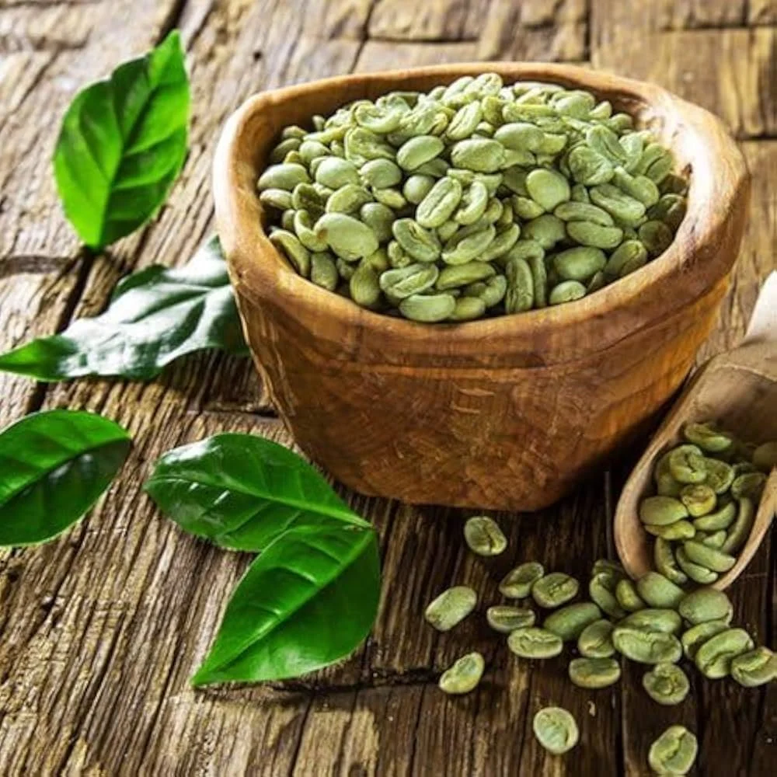

2. Arabica AA Grade Green Coffee Beans
Grade: AA
Blend Ratio: 100% Arabica
Color: Green
Form: Whole Beans
Processing: Natural sun-dried
Availability: In Stock

Features & Benefits
- Balanced Flavor: Offers a smooth, medium-bodied taste with mild acidity and a natural sweetness.
- Aromatic Excellence: Known for its refined fragrance, with hints of fruit, caramel, and nuts.
- Handpicked & Processed: Harvested manually to ensure only ripe cherries are used, followed by careful drying to maintain optimal moisture levels.
- Perfect for Export: A popular choice among roasters and coffee distributors for its consistency and value.

Suitable For
- Cafés and boutique coffee brands seeking 100% Arabica beans for signature blends.
- Exporters and wholesalers catering to global markets that demand authentic Indian Arabica.
- Home roasters looking for smooth and fresh green beans for custom roasting.

3. Arabica AA Grade Roasted Coffee Beans
Grade: AA
Roast Type: Medium / Dark (customized on request)
Color: Brown
Shelf Life: 12 Months
Usage: Brewing premium espresso, cappuccino, or filter coffee
Availability: In Stock

Characteristics
- Premium Roasted Perfection: Expertly roasted to enhance the natural oils and sugars, producing a cup that’s aromatic, bold, and smooth.
- Balanced Acidity: Ideal for espresso lovers who appreciate a rounded body and lingering aroma without bitterness.
- Freshly Packed: Sealed immediately after roasting to lock in freshness, flavor, and aroma.
- Versatile Brewing Compatibility: Perfect for espresso machines, moka pots, French press, or pour-over brewers.

Flavor Profile
Attribute | Description
Aroma | Strong and inviting with nutty and cocoa undertones
Flavor | Mild sweetness with medium acidity and a clean finish
Body | Full and rich, maintaining smooth texture
Aftertaste | Long, pleasant, and slightly fruity
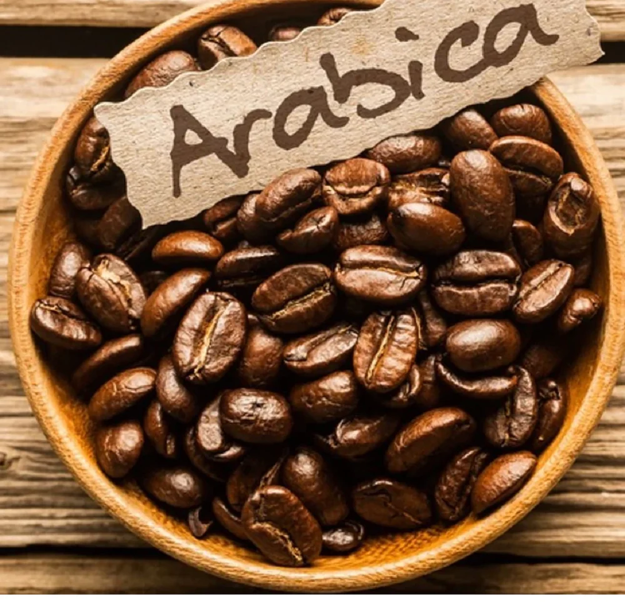

Understanding Arabica Coffee Grades (AAA vs AA)

AAA Grade
- Represents the highest grade of Arabica beans.
- Larger bean size, uniform shape, and excellent moisture balance.
- Known for exceptional clarity, refined flavor, and minimal defects.
- Premium choice for single-origin brews and luxury coffee lines.

AA Grade
- Slightly smaller in size than AAA but with superior aroma and consistency.
- Offers a balanced flavor, ideal for everyday high-quality brewing.
- Commonly used by cafés, premium blends, and export roasters seeking smoothness and body.
Both grades are 100% Arabica and comply with international coffee grading standards for purity, size, and moisture content.

Health & Nutritional Benefits of Arabica Coffee
- Rich in Antioxidants: Neutralizes free radicals and supports metabolic health.
- Promotes Alertness: The caffeine and theanine combination enhances focus without causing overstimulation.
- Supports Weight Management: Green coffee beans, particularly AAA grade, are naturally high in chlorogenic acid, known for boosting fat metabolism.
- Heart Health: Regular consumption of pure Arabica coffee is associated with improved circulation and cardiovascular benefits.
- Low Acidity & Gentle on Stomach: Compared to Robusta, Arabica offers smoother digestion and less acidity.

From Bean to Brew – The Art of Arabica Roasting
At The Export Express, our Arabica beans are processed and packaged with utmost precision to preserve their natural aroma and flavor.
- Sorting & Grading: Each bean is inspected for uniformity and quality.
- Sun Drying: Moisture is naturally reduced under controlled sunlight.
- Roasting: Conducted at optimal temperatures to unlock the bean’s unique characteristics.
- Degassing & Sealing: Roasted beans are allowed to degas before being vacuum-sealed to retain aroma.
- Packaging: Available in bulk gunny bags or retail pouches, customized for international shipping.


Why Choose The Export Express for Arabica Coffee
- Authentic Sourcing: Direct procurement from reputed high-altitude plantations.
- Quality Assurance: Every batch undergoes rigorous lab testing for moisture, aroma, and purity.
- Flexible Packaging: Available in bulk (25–60 kg) or custom retail pouches (250 g – 1 kg).
- Export Expertise: Certified for international trade with seamless logistics and documentation.
- Sustainability Commitment: Partnered with farms practicing eco-friendly cultivation and fair trade ethics.

Global Appeal of Indian Arabica
Indian Arabica coffees, especially from regions like Chikmagalur, Coorg, and Baba Budangiri, are renowned for their fine aroma, balanced flavor, and mild acidity. They are sought after by importers in Europe, the Middle East, Japan, and the United States for use in premium blends and single-origin labels.
The Export Express ensures each shipment meets the quality benchmarks demanded by international buyers, positioning Indian Arabica as a luxury commodity in the global coffee market.

Packaging & Export Options
Type | Form | Packaging | Shelf Life | Usage
Arabica AAA | Green Beans | Gunny Bag (Bulk) | 24 Months | Roasting / Health Drinks
Arabica AA | Green Beans | Gunny Bag / Retail Pack | 24 Months | Roasting / Blending
Arabica AA | Roasted Beans | Vacuum Pack / Retail Pack | 12 Months | Brewing / Café Supply
Custom branding, private labeling, and retail-ready packaging are available on request.

Conclusion
The Export Express stands as a trusted name in premium-grade Arabica coffee exports, offering the finest AAA and AA beans in both green and roasted forms. Each batch reflects our commitment to quality, purity, and taste — from the high-altitude farms of India to discerning coffee connoisseurs around the world.
Whether you’re a café owner, specialty roaster, or distributor, our Arabica coffee collection ensures consistency, luxury, and excellence in every cup.
Experience the world’s finest — Arabica Coffee from The Export Express.

